**Brain Task App Deployment - Screenshots**

**1. Git Clone the React build folder**

1a) Git Cloning the Repository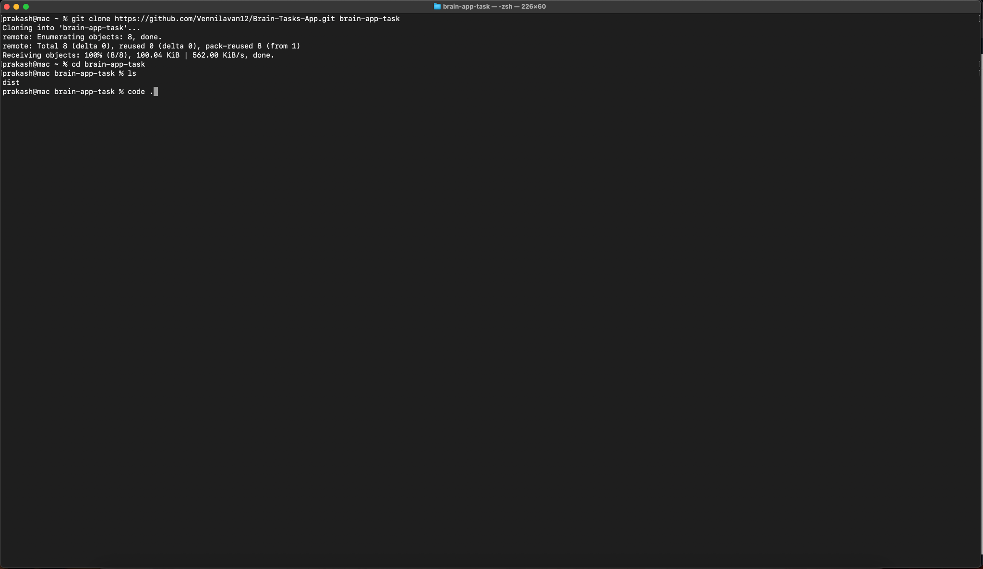

1b) Opening and Verification of Project Folder

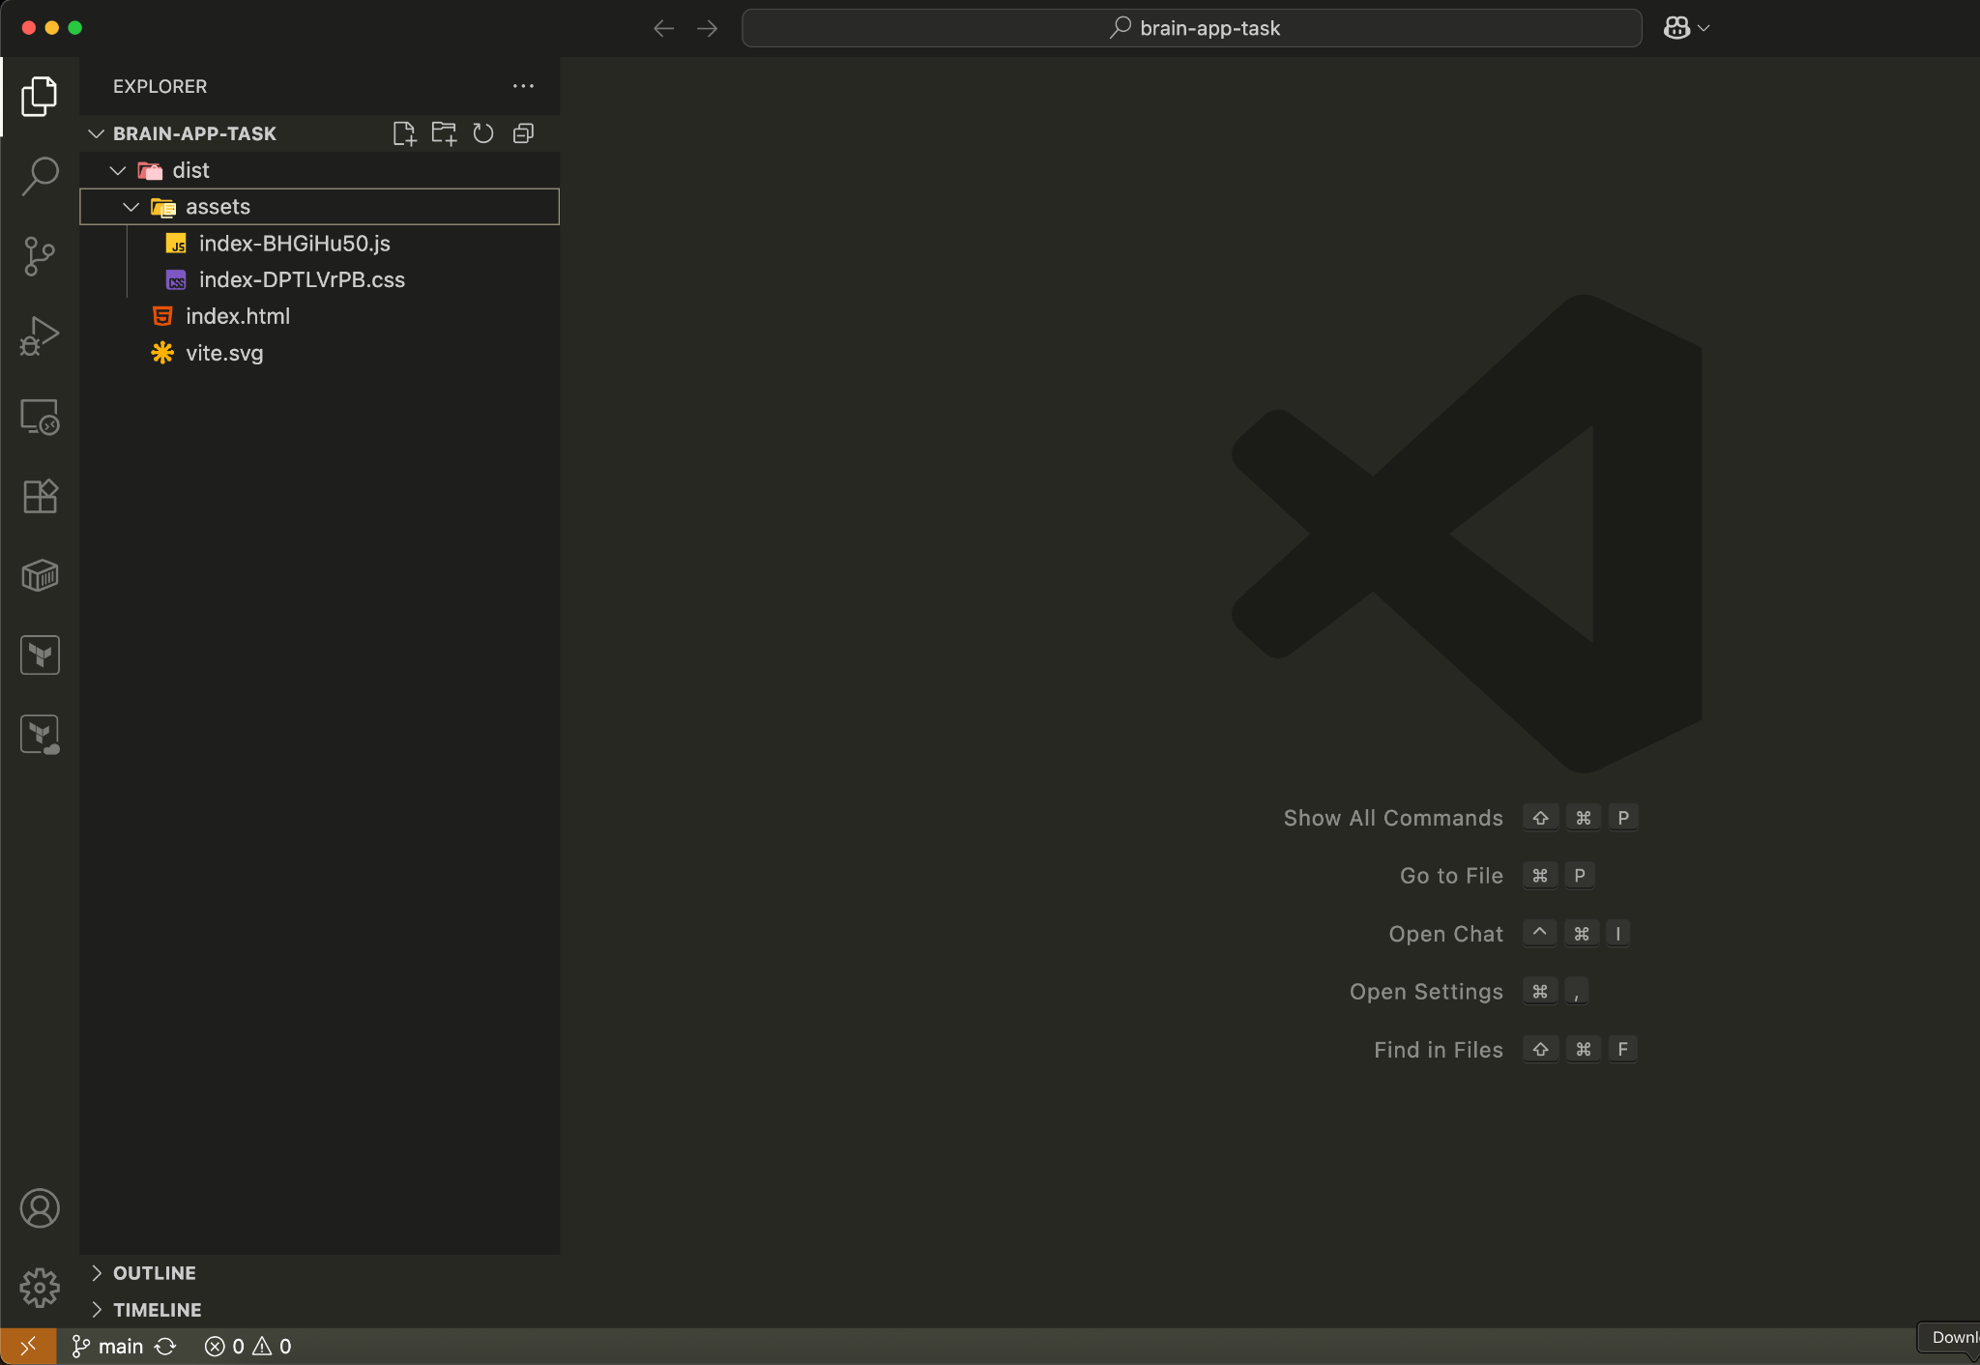

**—------------------------------------------------------------------------------------**

**2. Dockerize the App**

2a) Adding Dockerfile and creating image

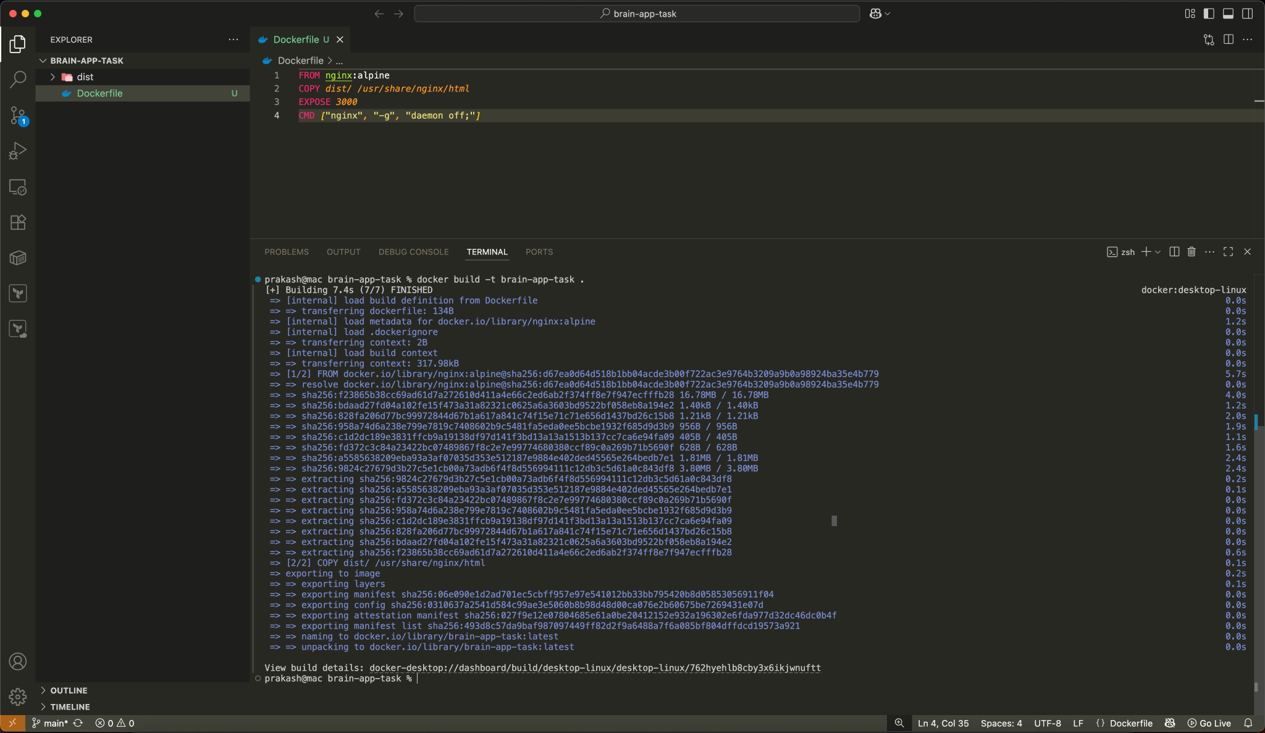

2b) Running created image on localhost 3000 post

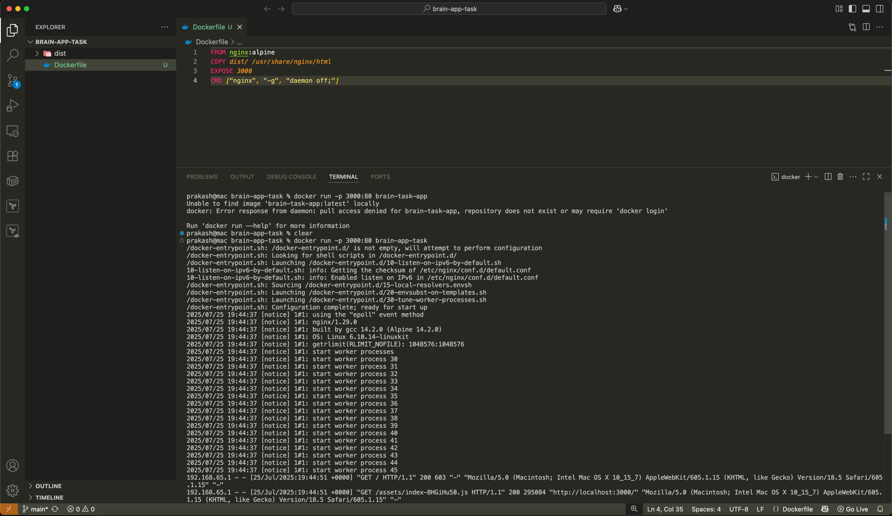

2c) Verification of App Running localhost 3000 port

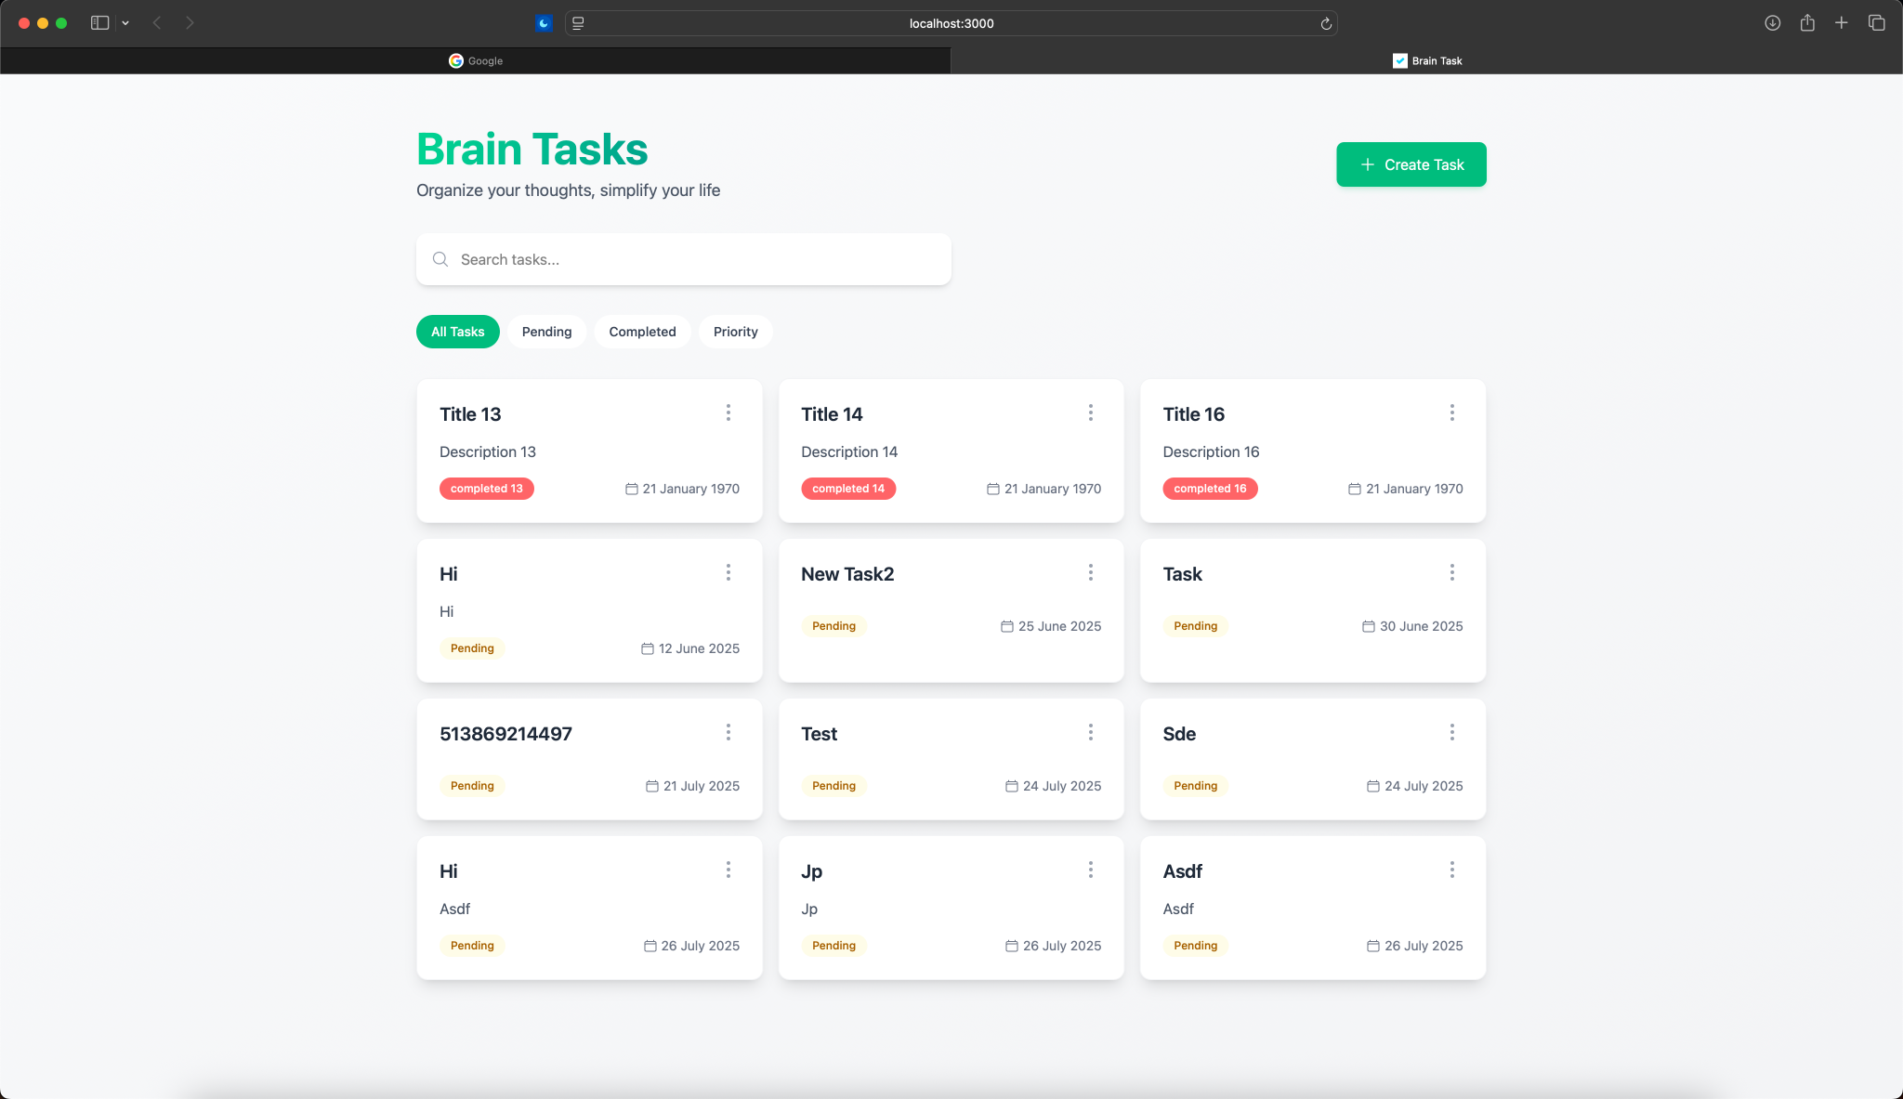

**—------------------------------------------------------------------------------------**

**3. AWS ECR config**

3a) Creating New Repo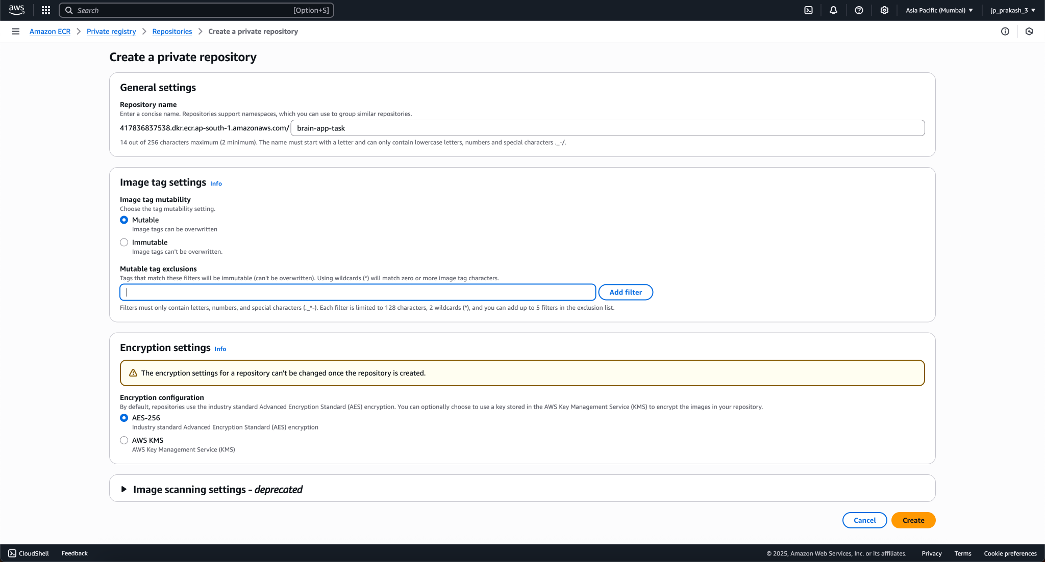

3b) Push Commands

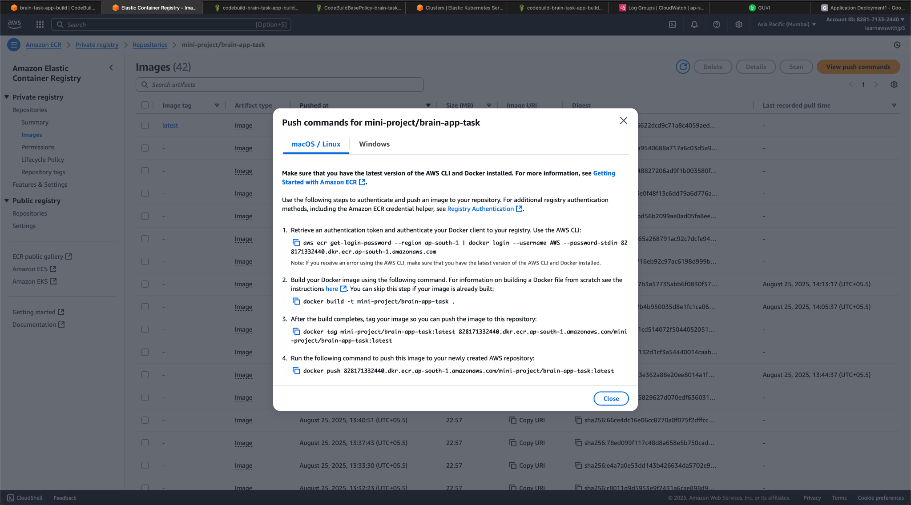

3c) Pushing image to new repo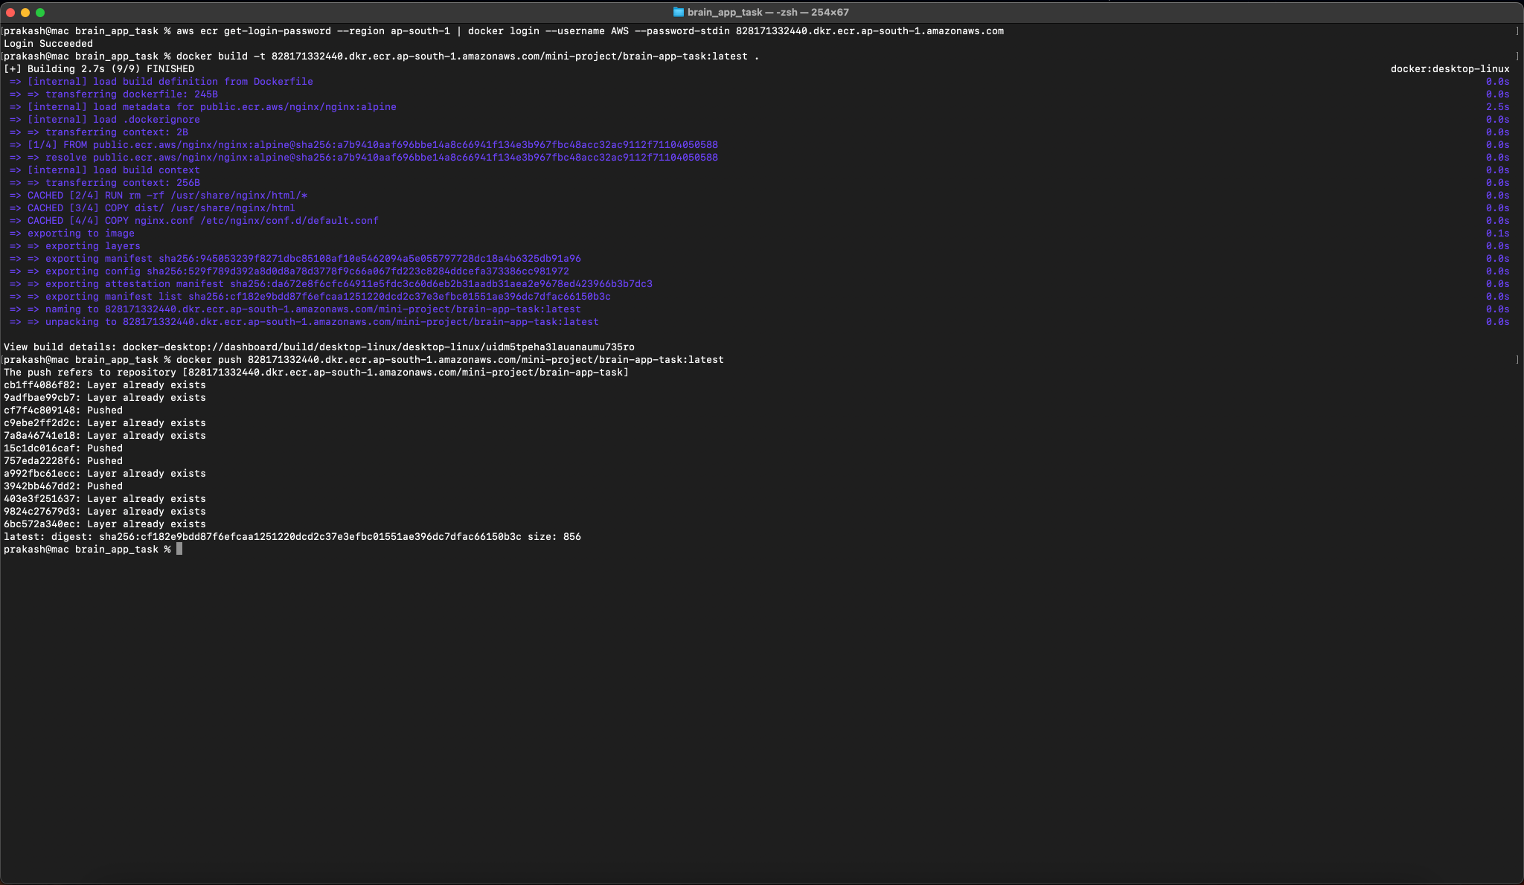

**—-------------------------------------------------------------------------------------------------**

**4. EKS setup and config**

4a) EKS cluster creation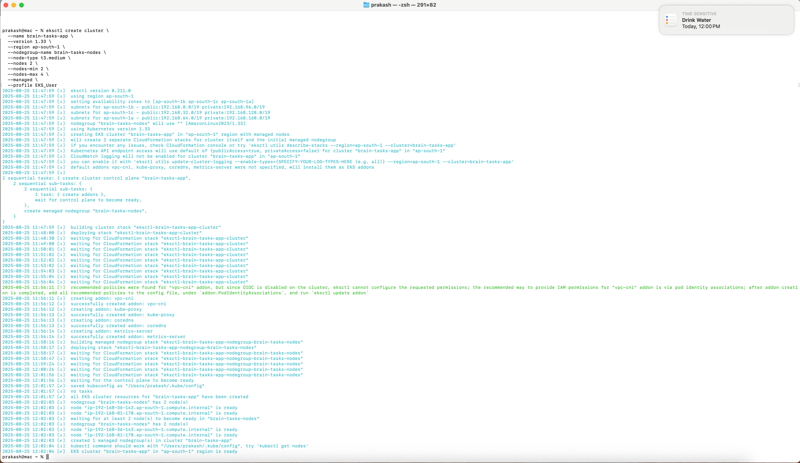

4b) Verifying Nodes and user Profile

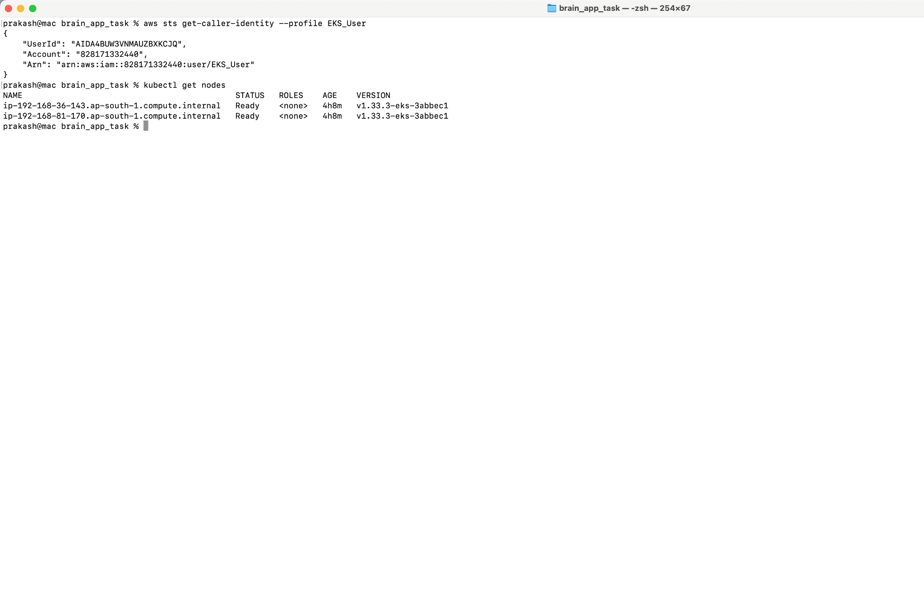

**—-------------------------------------------------------------------------------------------------**

**5. Git Setup and config**

5a) New Repo Created on Github

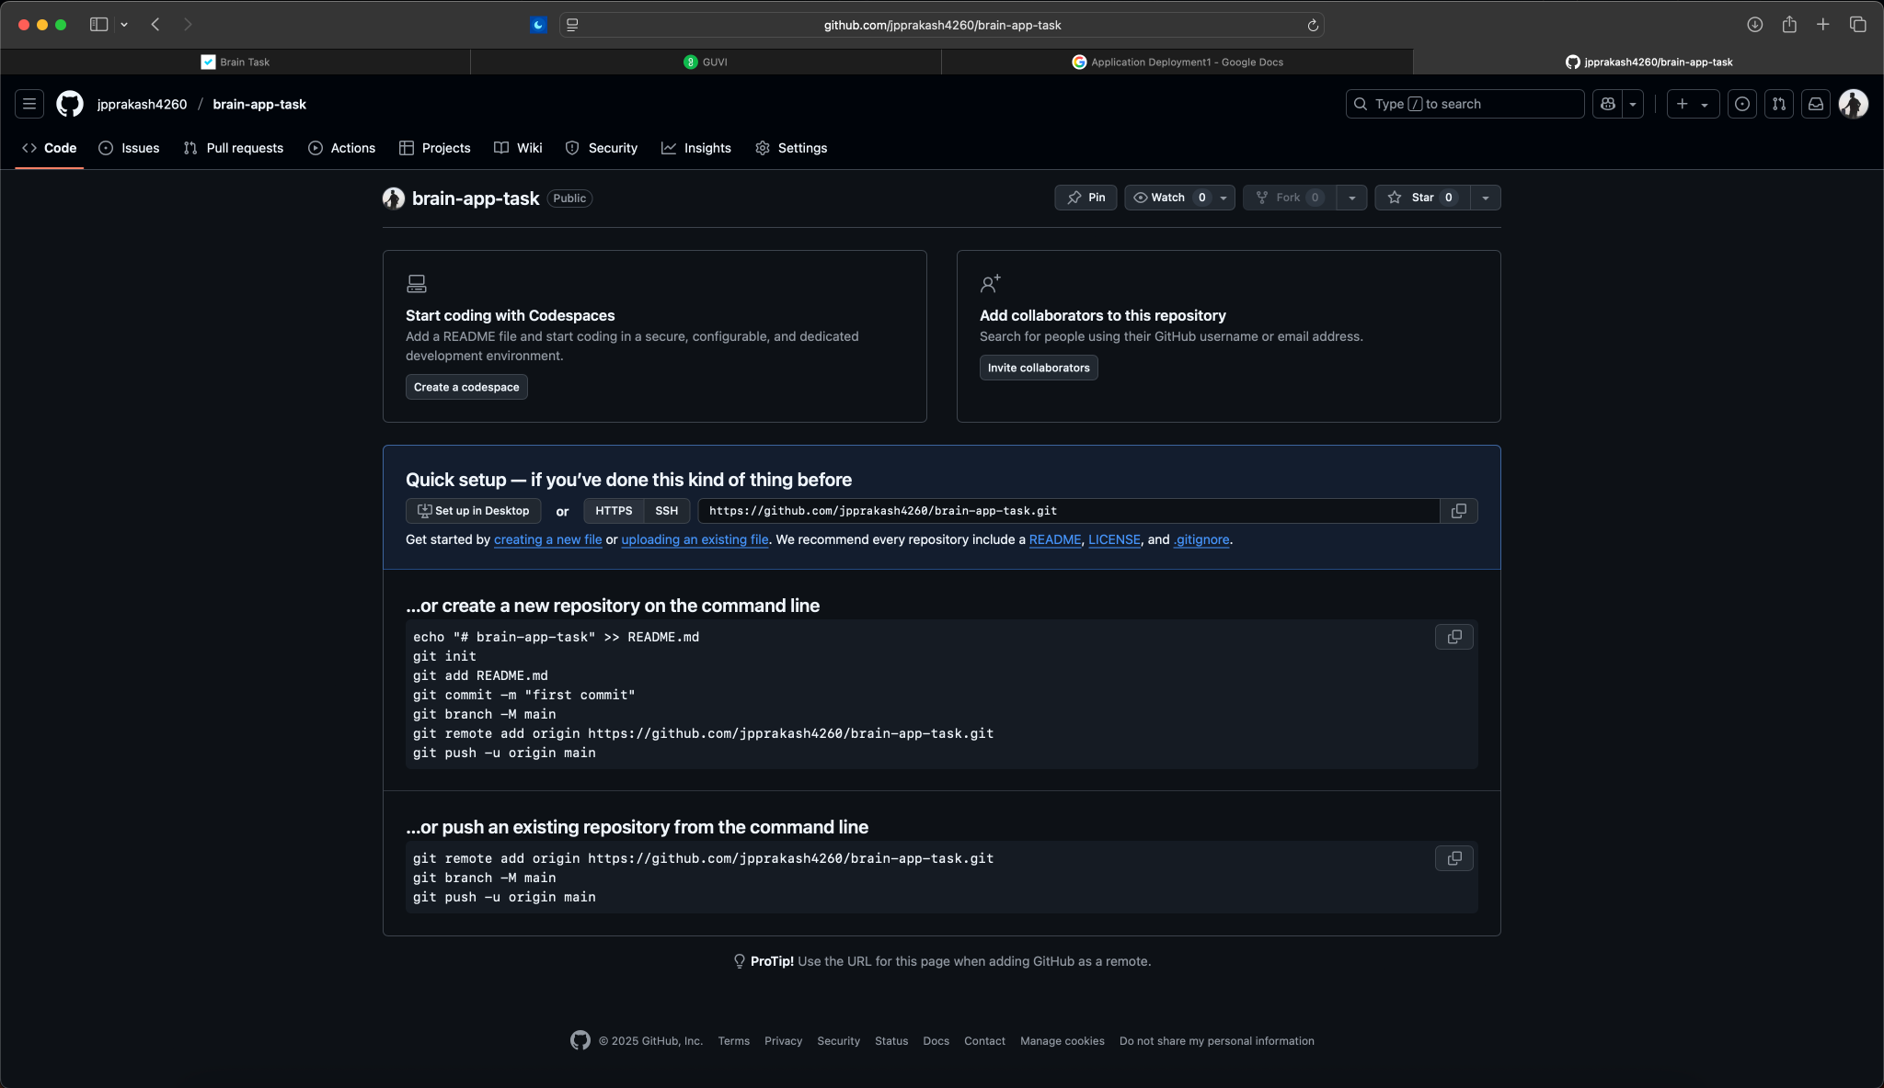

5b) Git Commands and pushing

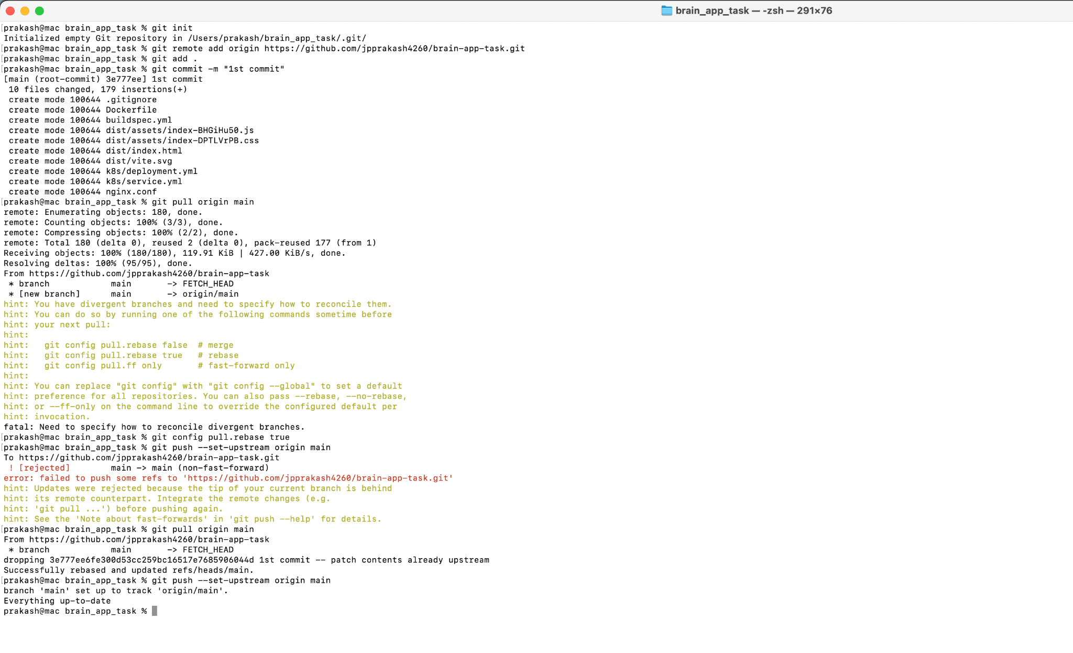

**—-------------------------------------------------------------------------------------------------**

**6. Code Pipeline**

6a) GitHub Connection Stage

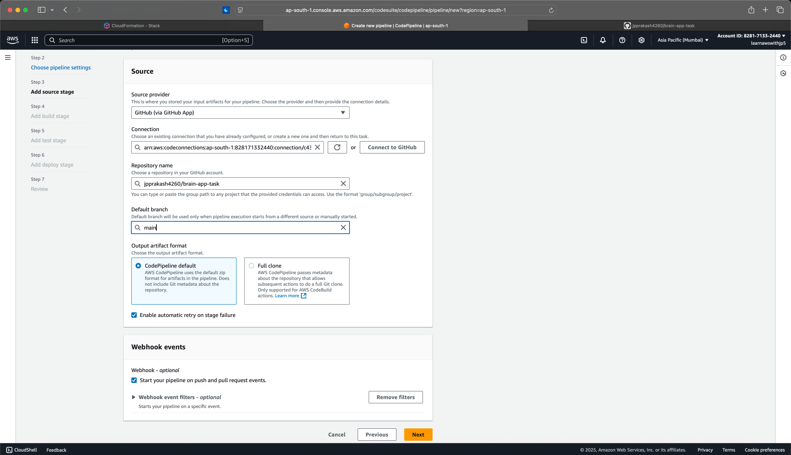

6b) Code Build Project

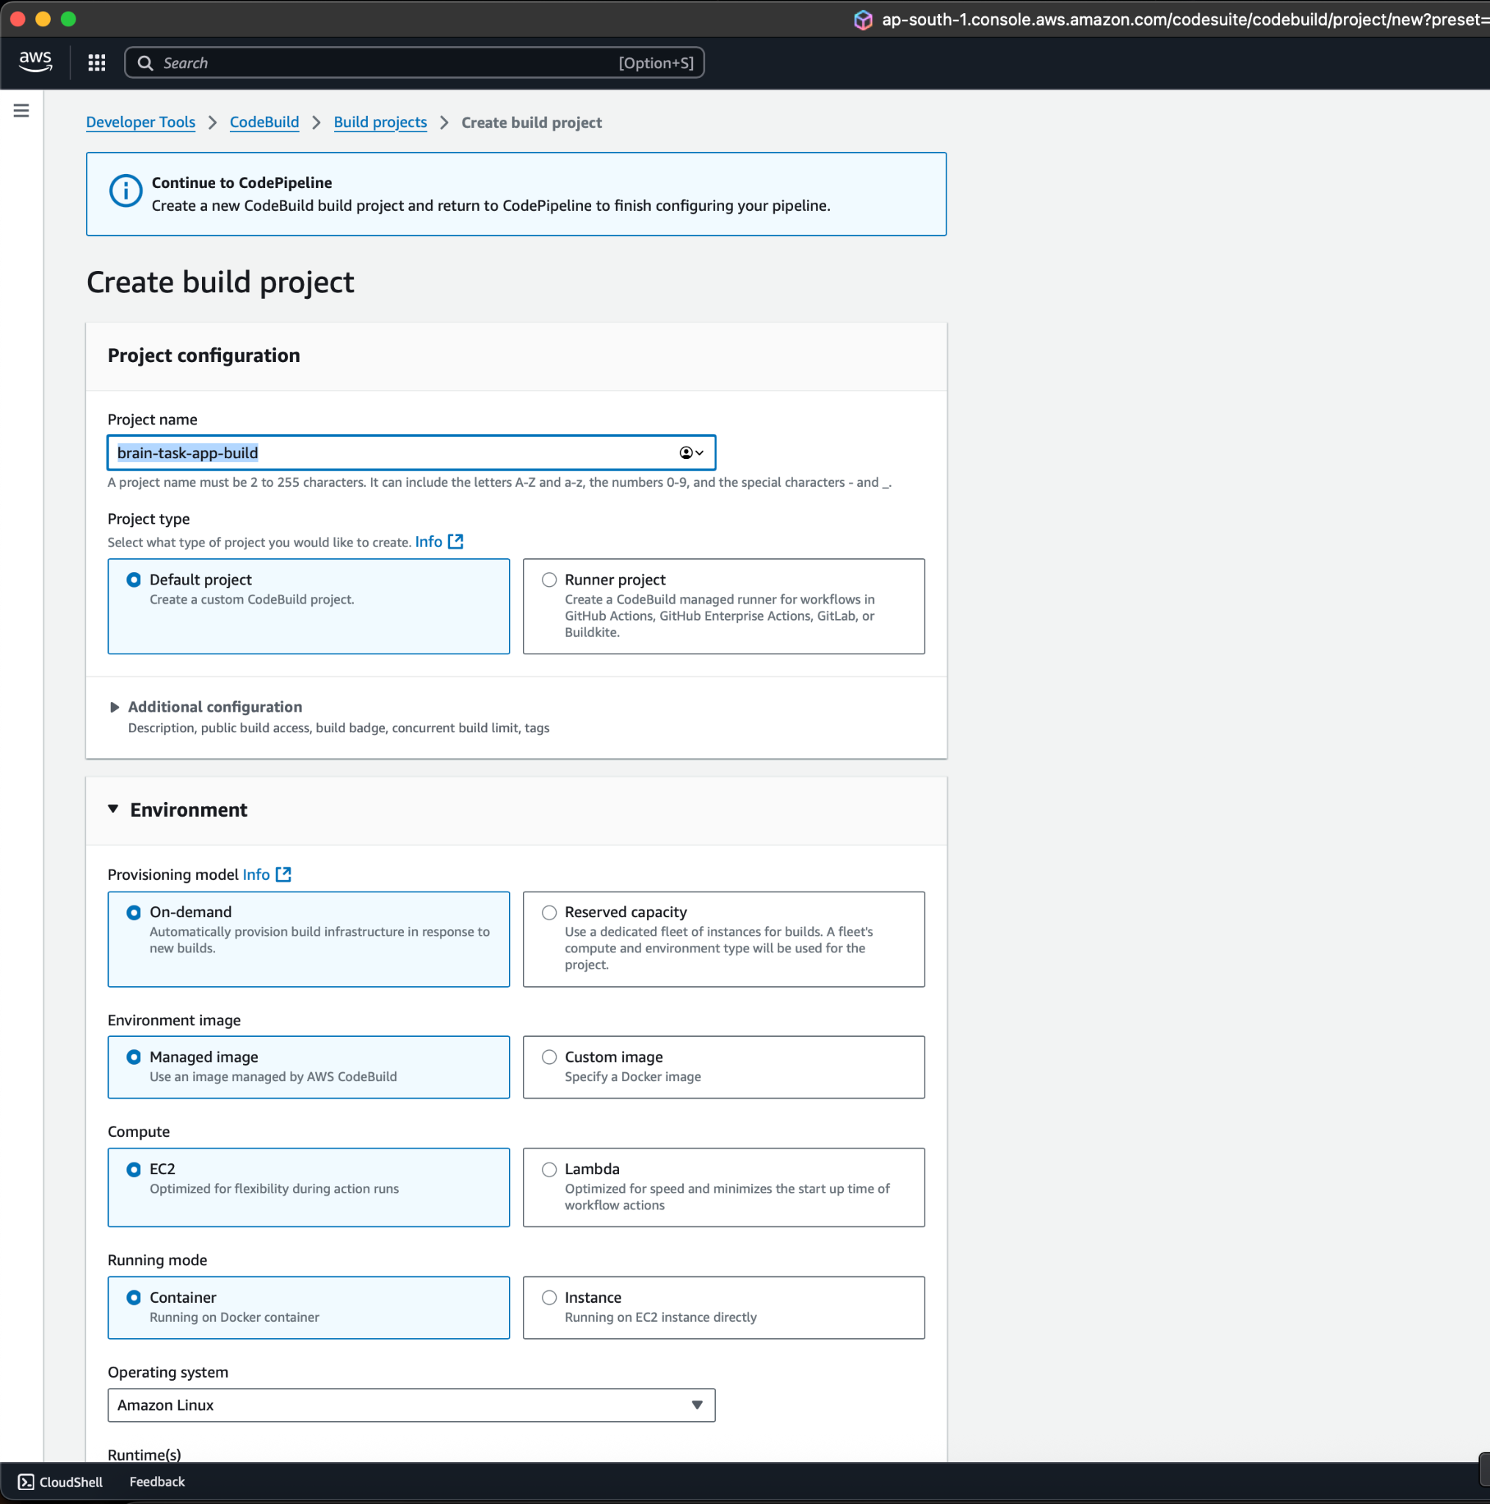

6c) Code Build Environment

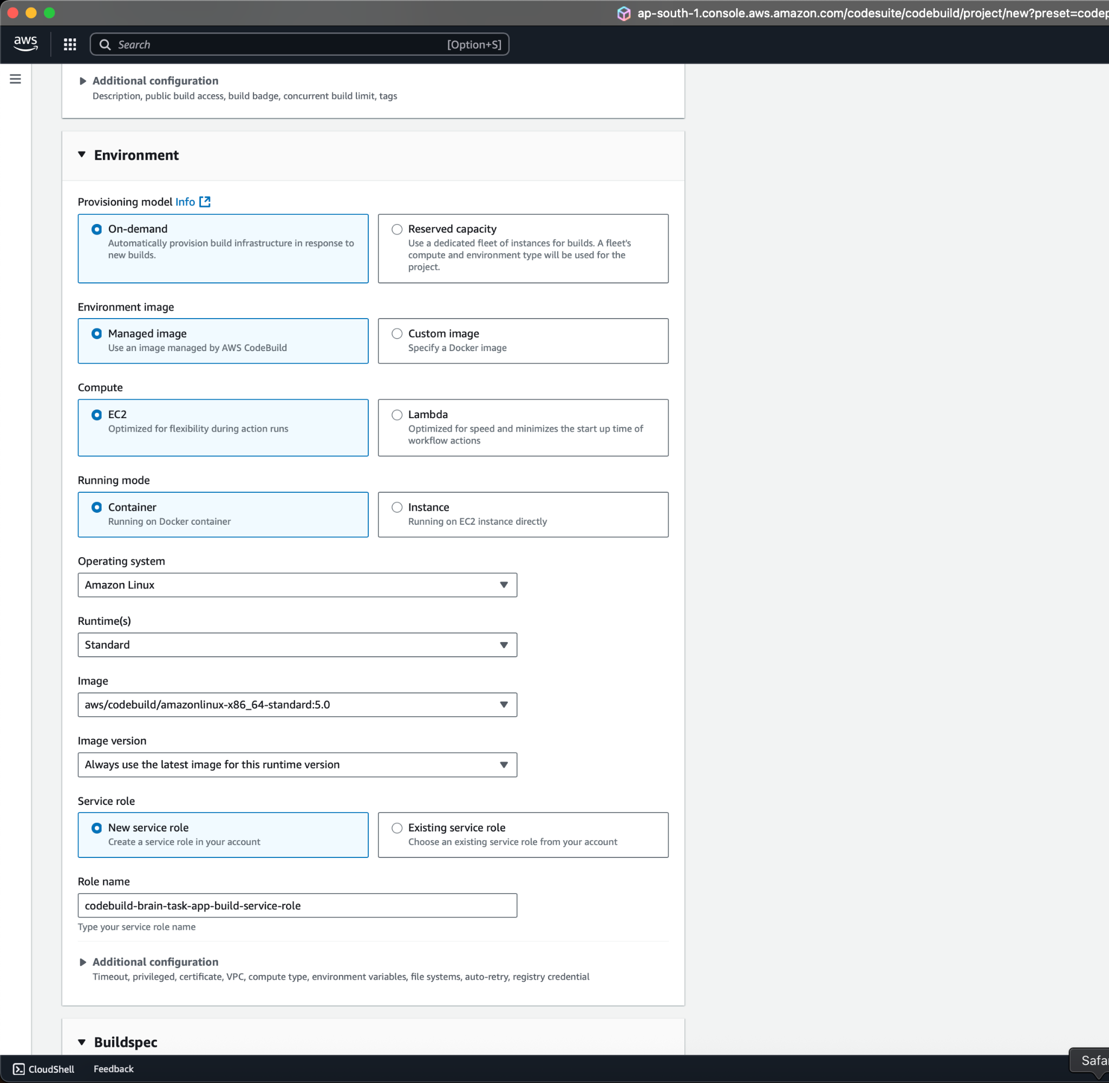

6d) Using buildspec.yml file

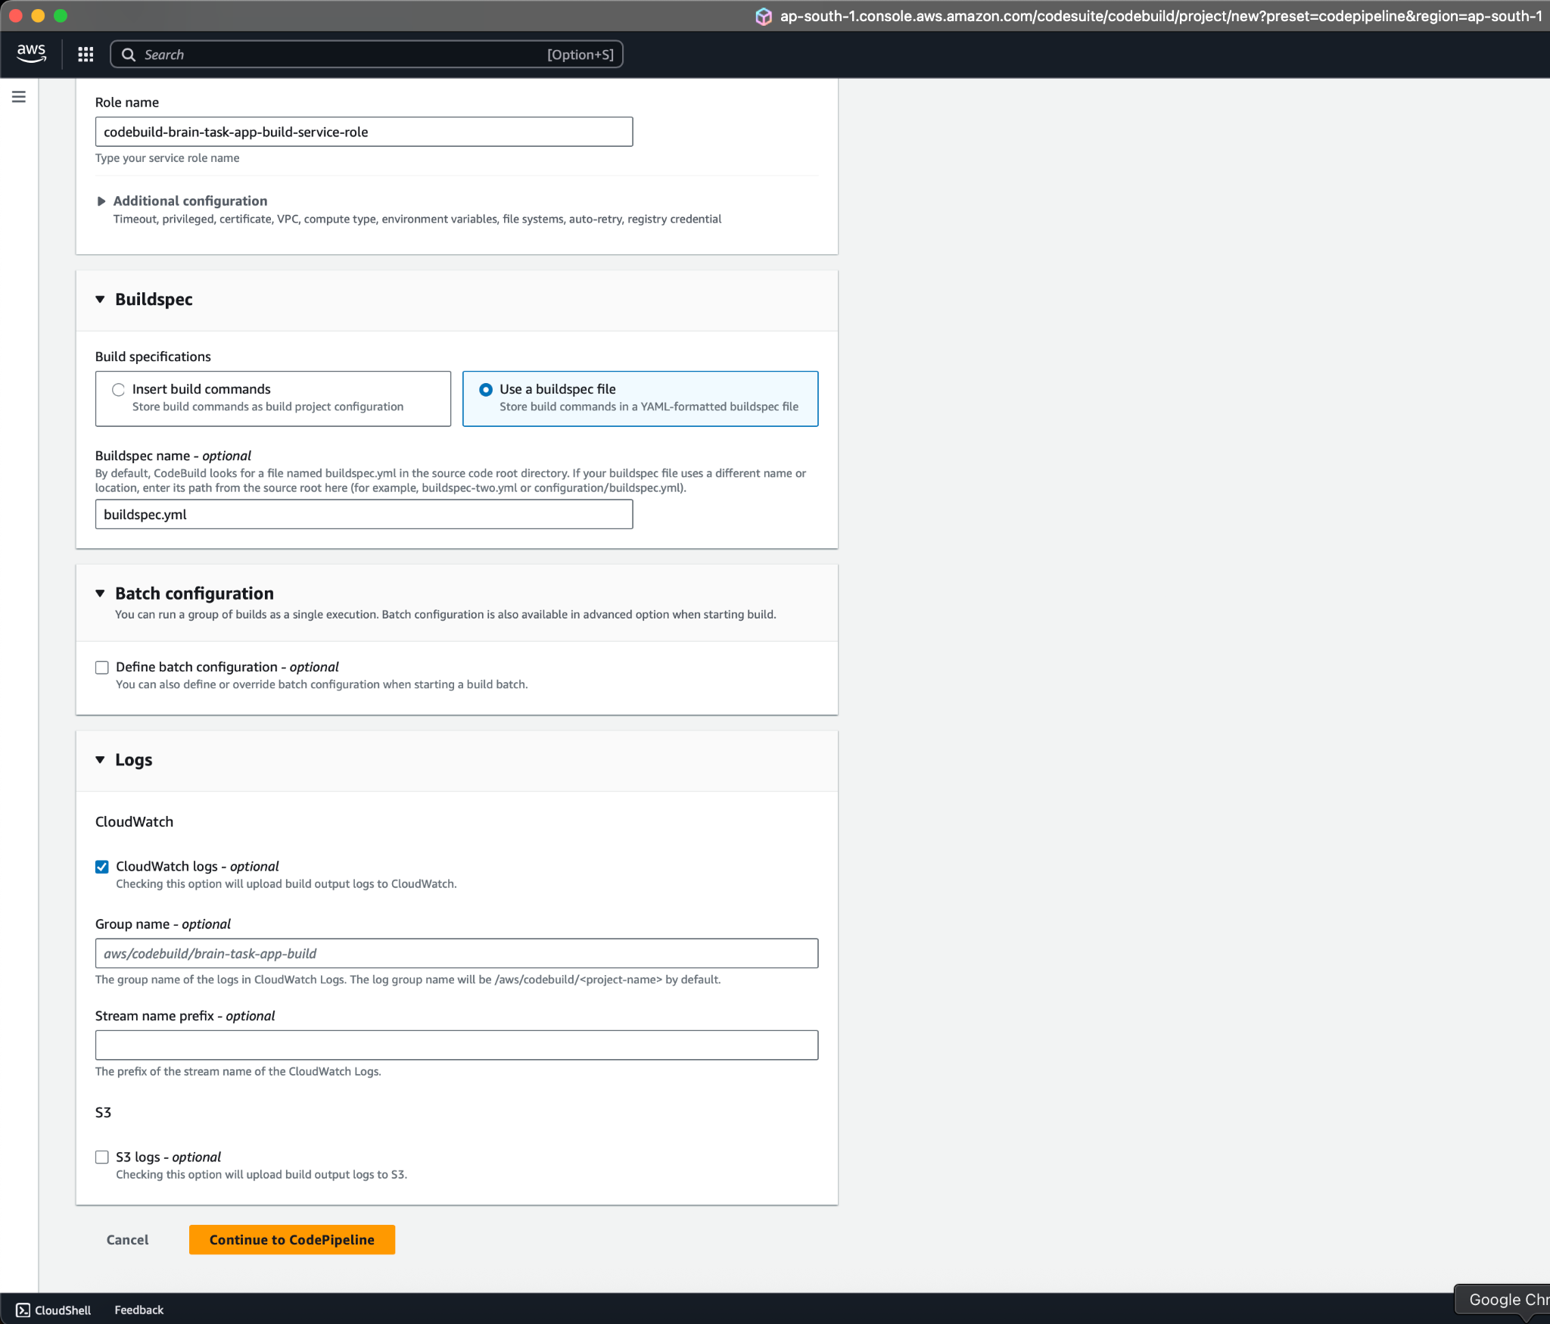

6e) Now Using Aws EKS for direct Deployment

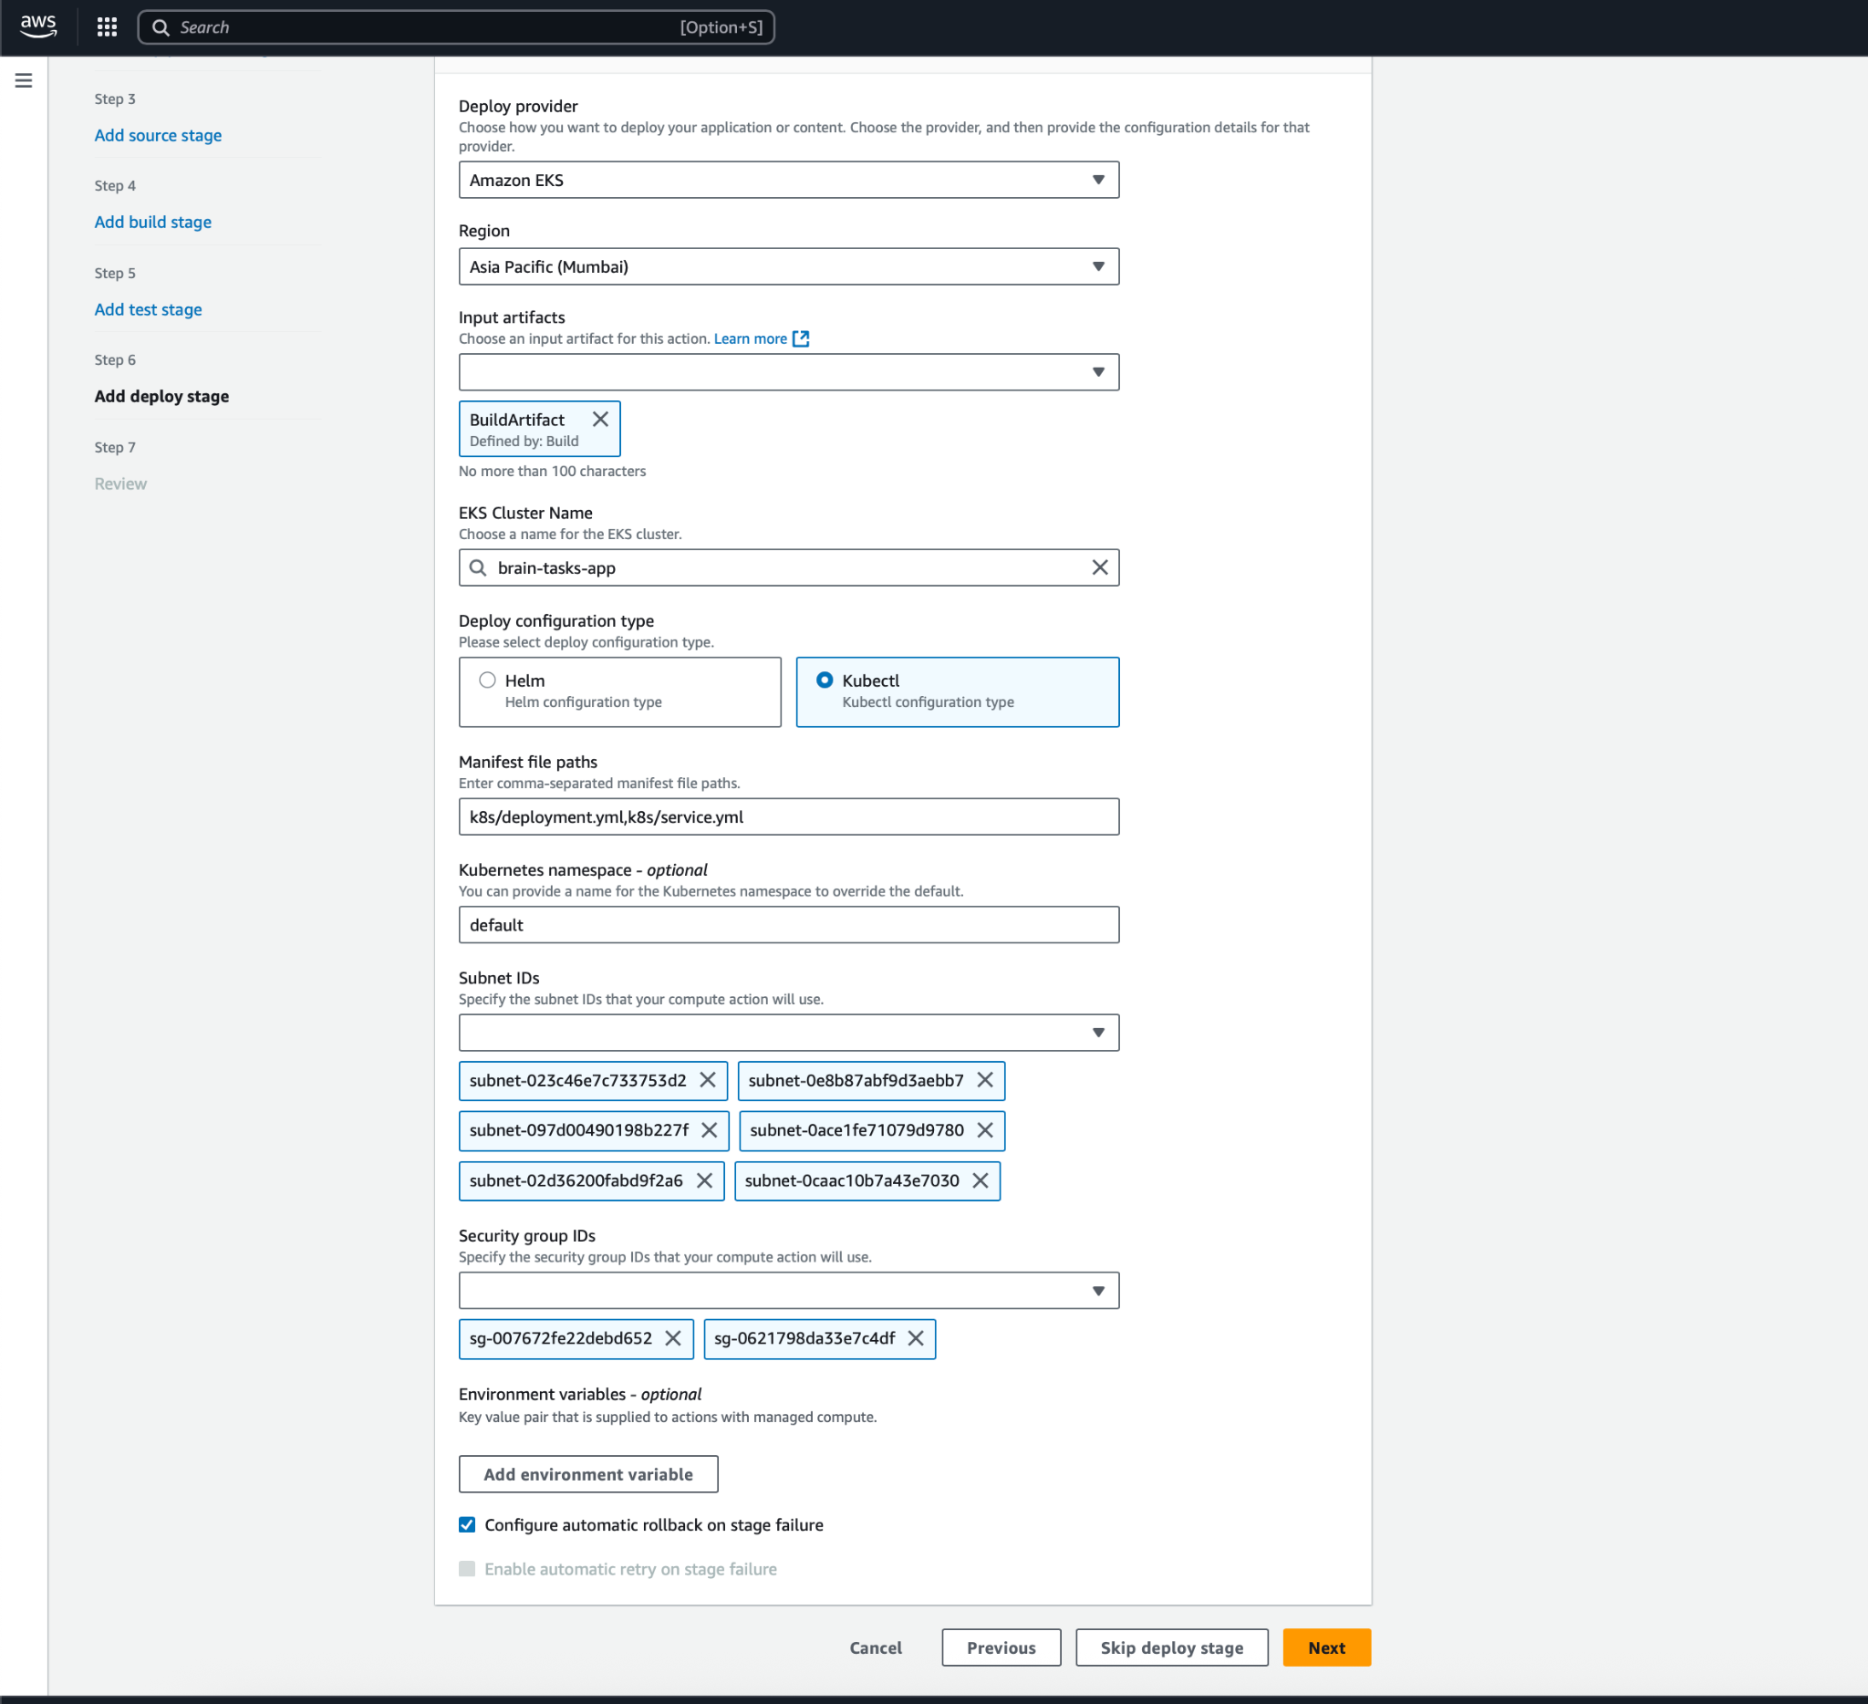

6f) Code Pipeline was Successfully Deployed

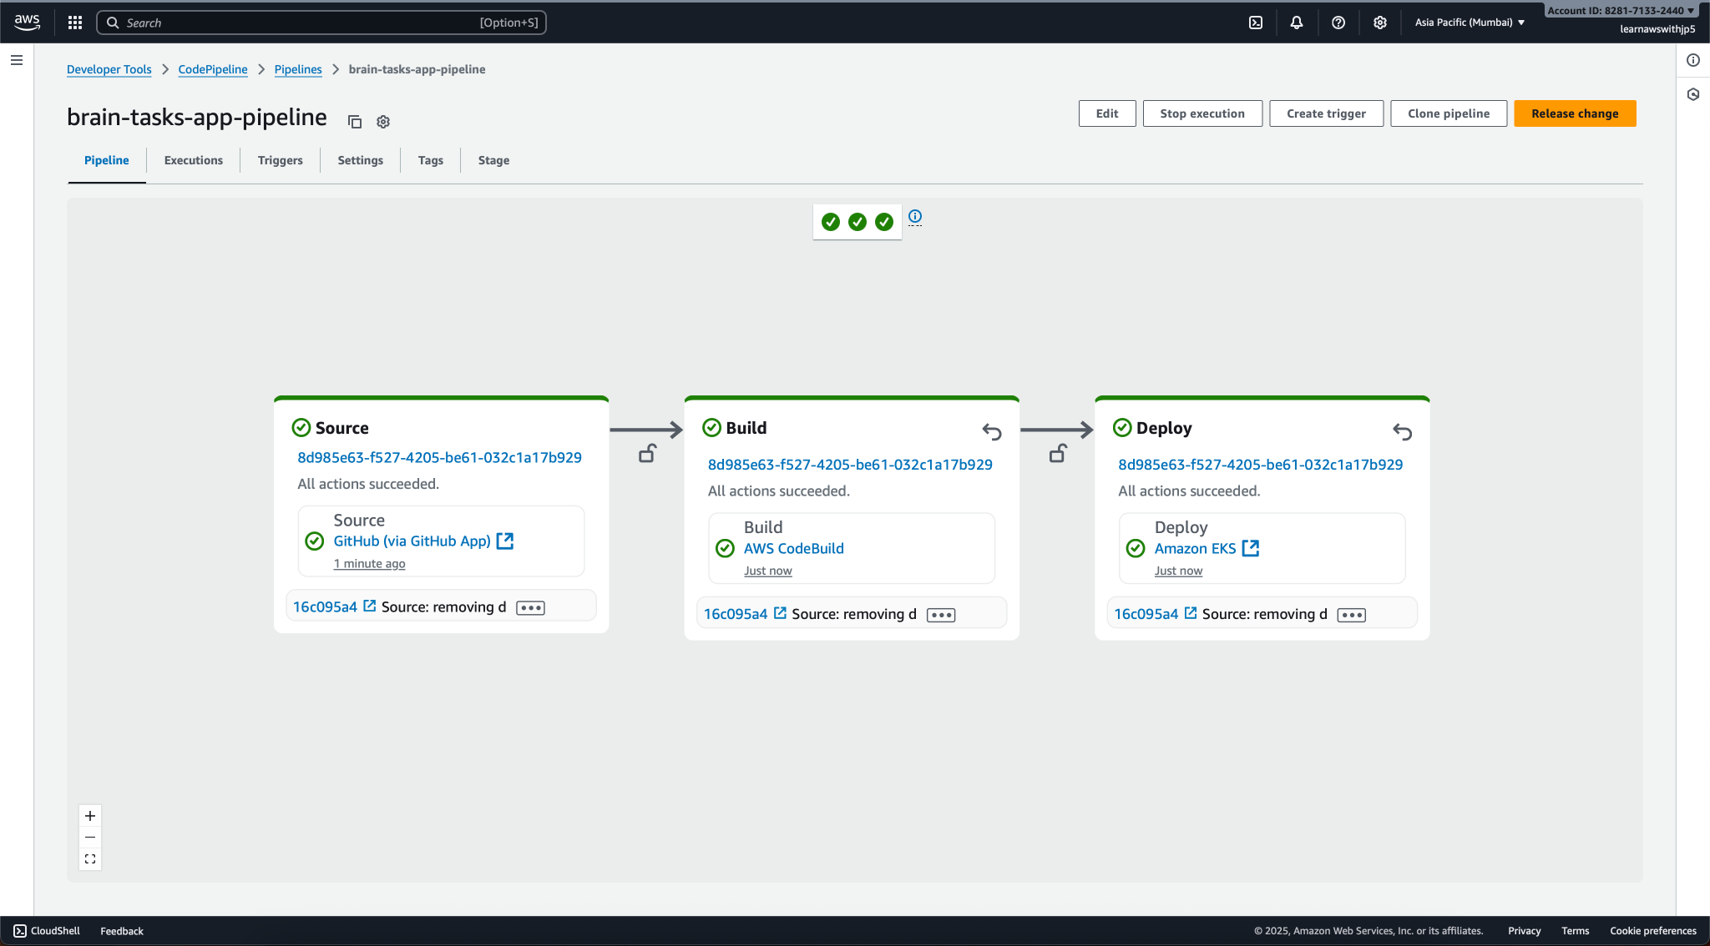

**—------------------------------------------------------------------------------------**

**7. App Testing**

7a) list pods and svc

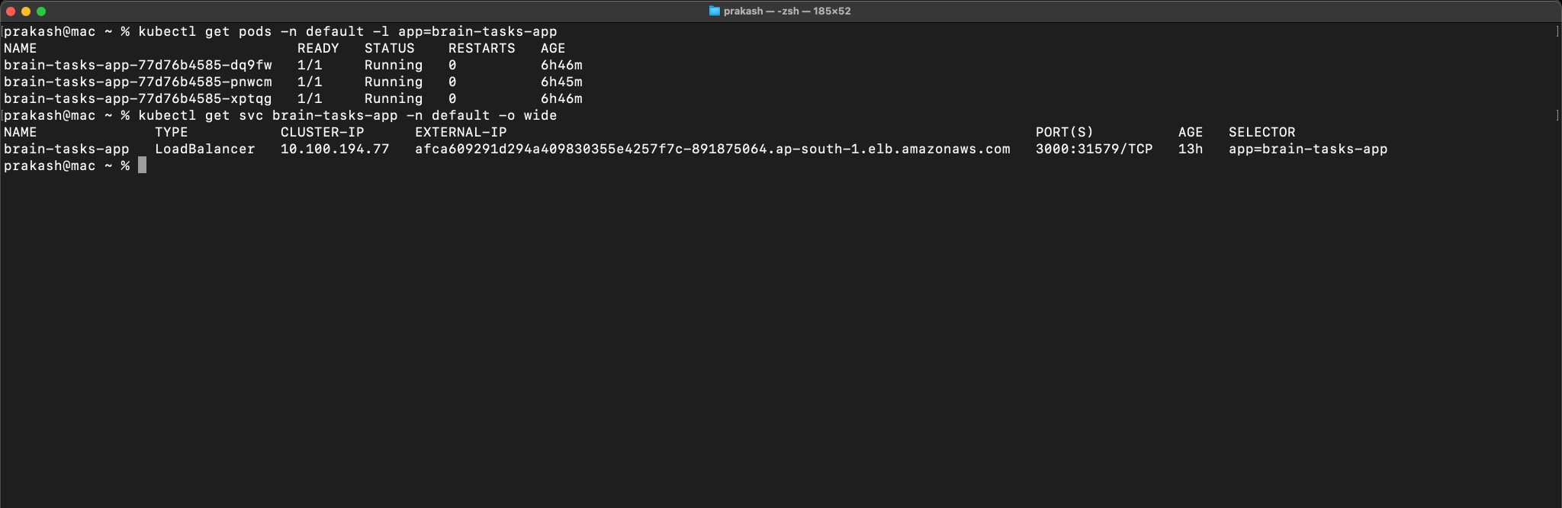

7b) Testing App with External IP on 3000 port

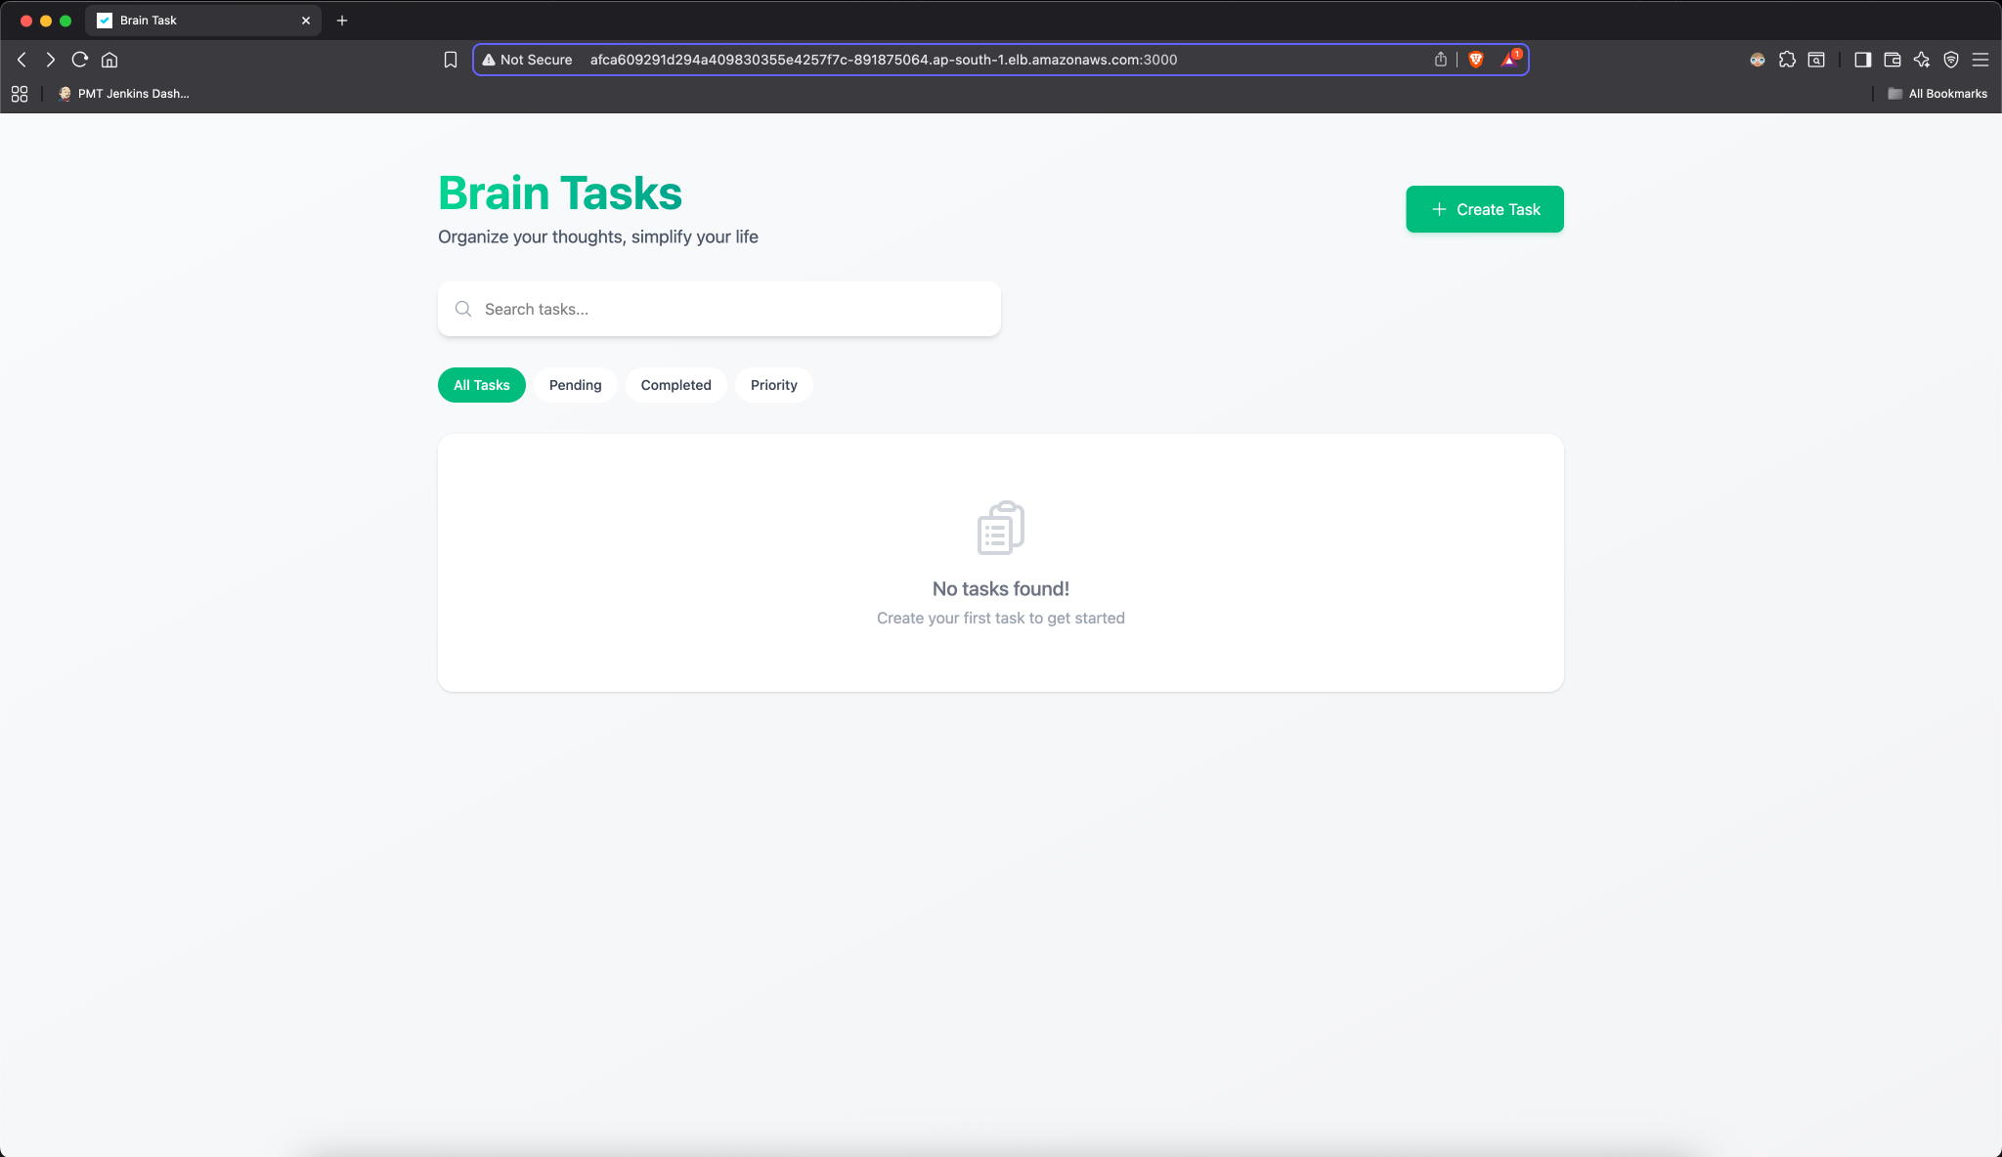

**—------------------------------------------------------------------------------------**

**8. Monitoring**

8a) CloudWatch Log

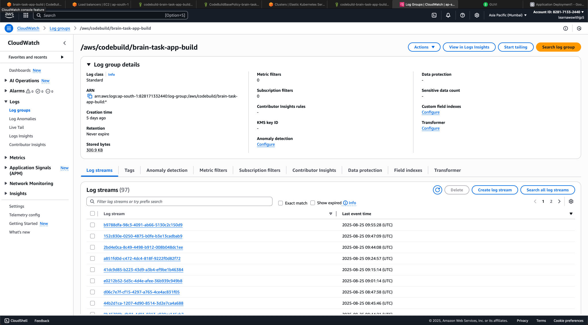

8b) While Code Build Project Creating Enabling CloudWatch Logs

